Report

Allsec Technologies Attrition Rate
______________________________________________________________________

Content:

1. Data pre-processing and EDA.

  - Data Loading
  - Load Libraries
  - Summary and dimensionality checking of the data.
  - Missing value Treatment.
  - Martial status
  - Working with date and finding out Age.
  - Managing address field
  - Managing Highest educational qualification
  - Managing Overall experience
  - Managing Length of Service
  - Managing Job Title
  - Defining Target variable
  - Feature Engineering (If any).

2. Visualization.

3. Model.
4. Time Series
5. Continual Service Improvement plan, prescriptive Analytics.

1. Data pre-processing and EDA
1.1 Data Loading

Below is the employee master data set you’ve loaded in R console and that’s showing 10095 data points each having 16 attributes. So dimensionality of the data is (10095*16).

Data Cleaning and Assumption:
Data information across 3 Databases.doc

Code:
Attrition Rate.R

Visualization & Findings (Descriptive Statistics)

Visualization with Power BI

Power BI visualization

1st Dashboard:

- Count of Employee by Job. Title and # Resigned.
Finding: Customer care Executive is the dominant resigned class.

- Count of Customer care Executive Employee by Supporting market
Finding: Samsung GA and Samsung TA is the dominant resigned class.

- Word Cloud Job Title and Analyze the sentiment.
Finding: Customer, Care and Executive are the Titles where sentiment accumulates.
- Customer care executive location pallet.

2nd Dashboard:

- Focusing on only Job title = Customer care Executive and Supporting Market.
Since, 2015 is only giving resigned data and not containing any live data we have discarded that year from filter and we see, last two year, i.e 2016-17 most attrition came from Samsung.

Further drilling down gave us most attrition came from sal bin – 0, 1 class.

3rd Dashboard:

- Gender wise Highest Educational qualification:
Finding: Most attrition came from Male Graduation class.

- Number of Employees by Final Age
Finding: 24 is the Age from where most attrition comes.
- Average Salary through Educational class.
Finding: HSC class is drawing more than Graduation and Diploma Class.

4th Dashboard:
- Count of Employee and Salary trend over the years .

5th Dashboard:
- 2017 Attrition Data EDA.

6th Dashboard:
- Forecasting attrition number.

Pipeline:
As suggested by HR Dept.
- Comparing Noida and Delhi Data (Sub process wise)
- Comparing cost and optimization of it.

Descriptive Statistics and EDA

> table(Test_Final_1$Gender,Test_Final_1$Marital.Status)

Married Single
F 668 2929
M 599 5326

> table(Test_Final_1$Highest.Educational.Qualification,Test_Final_1$Marital.Status)

Married Single
10th 5 78
Diploma 22 274
Graduation 643 4524
HSC 296 2105
Post Graduate Diploma 8 10
Post Graduation 235 438
Professional 17 15
PUC 41 811

> table(Test_Final_1$Resigned,Test_Final_1$Region_1)

Bangalore Chennai Dallas Hyderabad Manila Mumbai New Delhi Pune Trichy
0 570 3013 0 16 0 204 3546 27 101
1 299 795 0 4 0 117 811 3 16

> table(Test_Final_1$Overall.Experience,Test_Final_1$Resigned.y)

0 1
1Year 298 80
2Year 4674 1424
3Year 61 49

> table(Test_Final_1$Length.of.Service,Test_Final_1$Resigned.y)

0 1
0 0 0
1 1892 1008
10 4 23
11 11 36
12 10 31
13 7 19
14 3 23
15 0 11
16 2 10
17 3 8
18 0 4
2 2548 354
3 2126 177
4 570 101
5 150 61
6 49 42
7 63 73
8 32 38
9 7 26

> table(Test_Final_1$Resigned.y,Test_Final_1$Region_1)

Bangalore Chennai Dallas Hyderabad Manila Mumbai New Delhi Pune Trichy
A 299 795 0 4 0 117 811 3 16
I 570 3013 0 16 0 204 3546 27 101

> table(Test_Final_1$Resigned.y,Test_Final_1$Sal_bin)

0 1 2 3 4 5 6
A 131 232 147 129 118 110 1178
I 2240 1766 1014 712 523 381 841

> table(Test_Final_1$Resigned.y,Test_Final_1$Gender)

F M
A 724 1321
I 2873 4604

> table(Test_Final_1$Resigned.y,Test_Final_1$Marital.Status)

Married Single
A 396 1649
I 871 6606

> table(Test_Final_1$Sal_bin)

0 1 2 3 4 5 6
2371 1998 1161 841 641 491 2019

Density Curve visualization:

About Density Curve:

A density curve is a graph that shows probability. The area under the density curve is equal to 100 percent of all probabilities. ... Density curves can be a skewed distribution. Note that the right- or left-skew doesn't refer to how the graph looks. It refers to whether the data is skewed

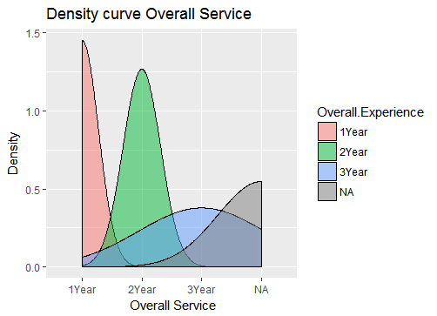

This graph depicts the density plot of the Overall Service of the employees.
For the sake of aesthetics all those with experience greater than 3 years have been put into the NA bin. One can infer the relation between number of people and overall experience.

Age Vs Salary

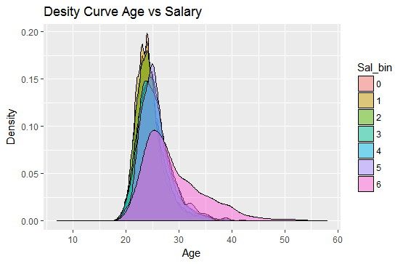

This graph depicts the density plot of the Age of the employees with information of the salary they draw. Here the salary is divided into bins where [0,7] depicts salary from 20k and below to 140K and above. One can infer the relation between number of people belonging to different age groups and salary drawn by them.

Age Vs Marital Status

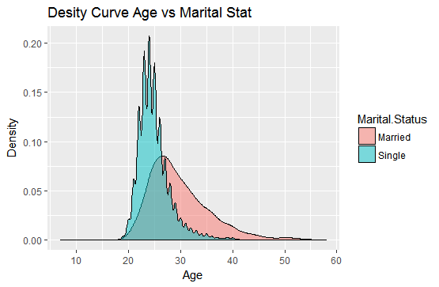

This graph depicts the density plot of the Age of the employees with information of their Marital Status. One can infer the relation between number of people belonging to different age groups and their marital status. As we can see, between ages of 20-30 the number of single people is greater than the number of married people and from age 30 and above the vice versa is true.

Boxplot with 3 Variables:

ABOUT BOXPLOT:
A simple way of representing statistical data on a plot in which a rectangle is drawn to represent the second and third quartiles, usually with a vertical line inside to indicate the median value. The lower and upper quartiles are shown as horizontal lines either side of the rectangle.

gENDER VS AGE

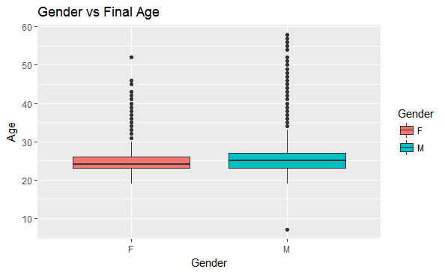

This graph depicts the box plot of the Age of the employees with information of their Gender. One can infer the relation between number of people belonging to different age groups and their gender. As we can see there are a numbers of outliers in both genders.
Average age of both genders is around 25 years.

GENDER VS AGE VS RESIGNED STATUS
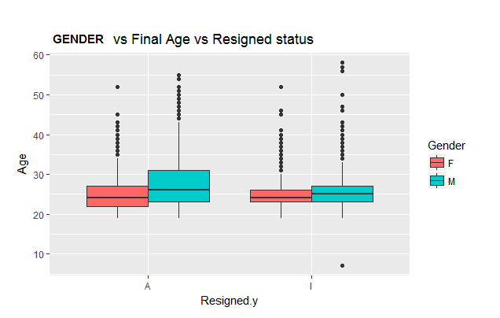

This graph depicts the box plot of the Age of the employees with information of their Gender and the resigned status. One can infer the relation between number of people belonging to different age groups, gender with attrition. As we can see there exist a number of outliers. Average age of both genders in both resigned status classes is around 25 years.

MARITAL STAUS VS FINAL AGE

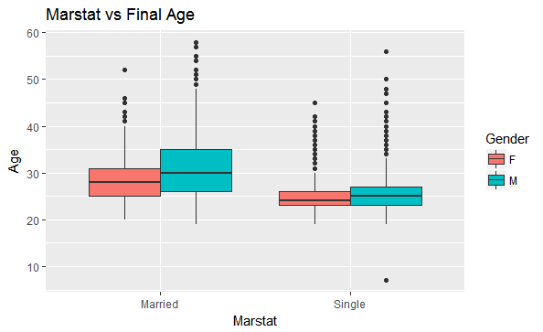

This graph depicts the box plot of the Age of the employees with information of their Gender and the marital status. One can infer the relation between numbers of people belonging to different age groups, gender with marital status. As we can see there exist a number of outliers. Average age of both genders in married classes is around 25 years.

ABOUT SCATTER PLOT:

A scatterplot is a useful summary of a set of bivariate data (two variables), usually drawn before working out a linear correlation coefficient or fitting a regression line. It gives a good visual picture of the relationship between the two variables, and aids the interpretation of the correlation coefficient or regression model.

Region vs Gross pay Distribution

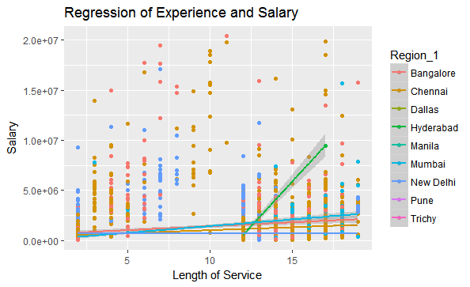

The above graph is a scatter plot between length of service and salary with trend lines which is color coded based on the region the employees work in. From these trend lines we can observe how salary gradually increases as length of service increases. Except for Hyderabad where the increase is abnormal.

REGRESSION OF AGE VS SALARY

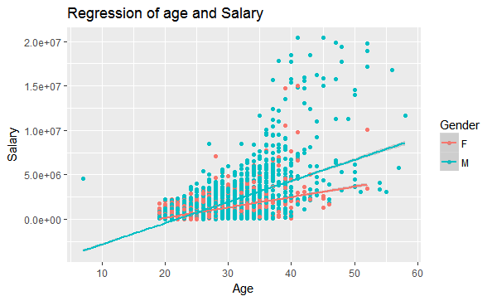

The above graph is a scatter plot between Age and salary with trend lines which is color coded based on the gender of the employees. From these trend lines we can observe how salary gradually increases as Age increases. The rate of increase in salary for men is much more than that of female employees.

ABOUT HISTOGRAM:

A diagram consisting of rectangles whose area is proportional to the frequency of a variable and whose width is equal to the class interval.

Final Age Distribution:

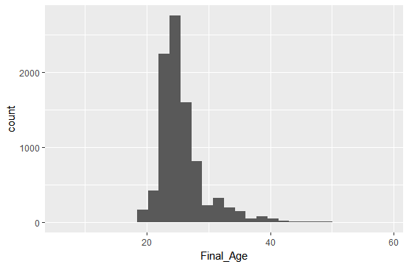

FInal age vs gross pay distribution

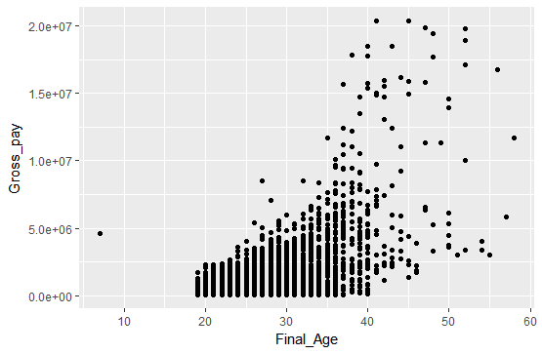

As we can see there are a lot of outliers in the age distribution. And number of outliers increases after the age of 40.

Length of Service vs Gross Pay distribution
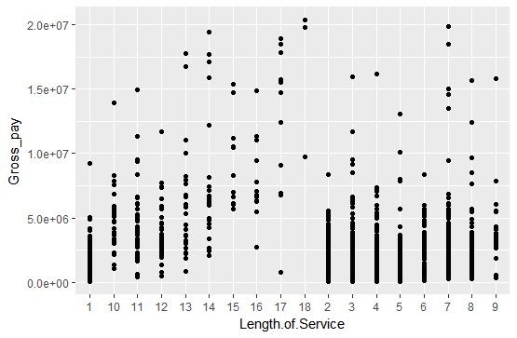
MARITAL STATUS VS GROSS PAY

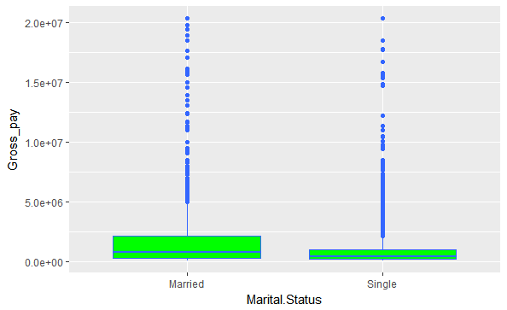

The above is a box plot of marital status versus the gross pay. In both classes there are a number of outliers.

GENDER VS SALARY BIN

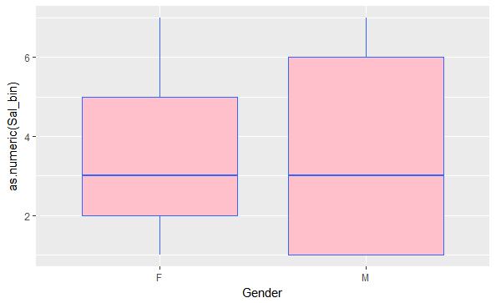
Age Distribution region wise
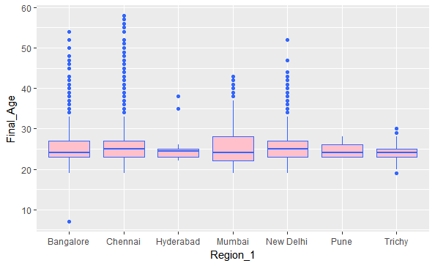

The above is a box plot of region versus age . In all classes there are a number of outliers.

Tree Model: Visualization

Full Model
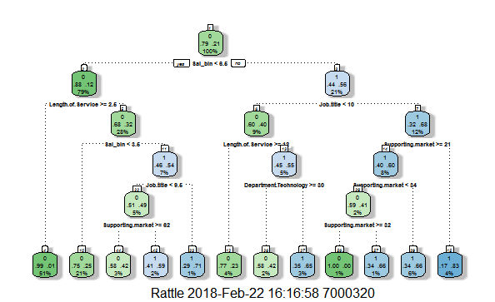

Modification:
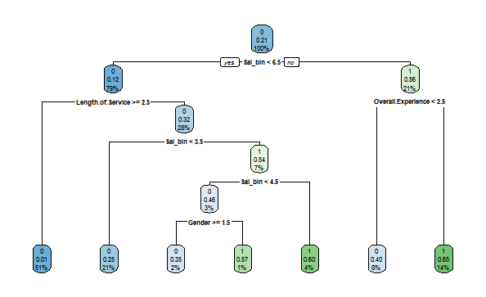

FancyRpartPlot:

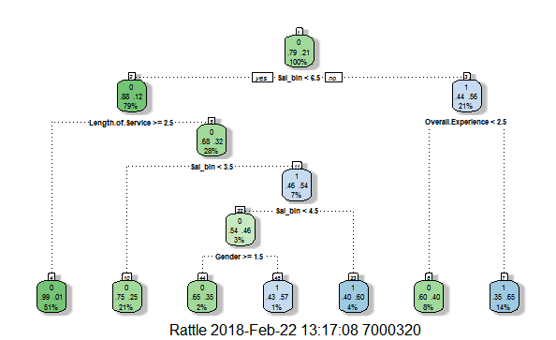

Attrition Pathway:

- Salary bin is the first deciding factor here. Salary bin < 5.5 first attrition. (79%)
- Salary bin < 5.5 and Length of Service >= 1.5 giving pure node of attrition. (51% of previous node)
- Length of Service < 1.5 + Salary bin < 2.5 (21 % of previous node)
- Length of Service < 1.5 + Salary bin > 2.5 – Negative Attrition (7% of previous node)
- Length of Service < 1.5 + Salary bin < 3.5 – 3 % of previous node.
- Length of Service < 1.5 + Salary bin < 3.5 + Gender = Female (2 % of previous node)
- Length of Service < 1.5 + Salary bin < 3.5 + Gender = Male- Negative Attrition (1 % of previous node)
- Length of Service < 1.5 + Salary bin > 3.5 – Negative Attrition (4% of previous node)
- Salary bin > 5.5 – Negative attrition (21%)
- Salary bin > 5.5 + overall. Experience < 1.5 = 8 % of previous node.
- Salary bin > 5.5 + overall. Experience > 1.5 = Negative Attrition 14 % of Previous Node.
- Neural Network Model:

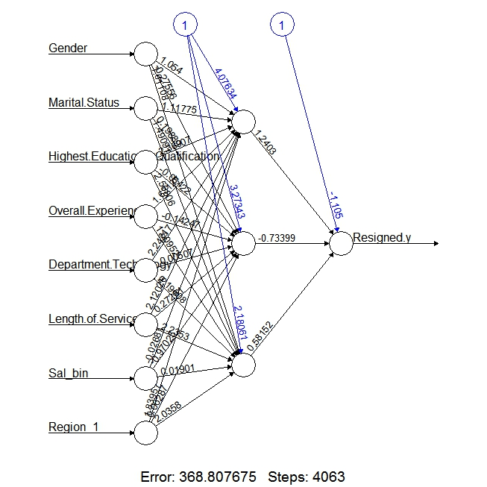

AUC Curve:

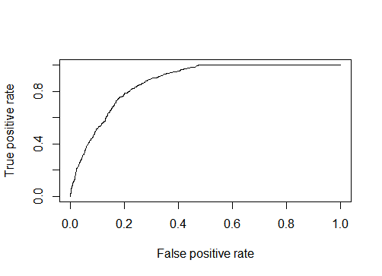

Random Forest

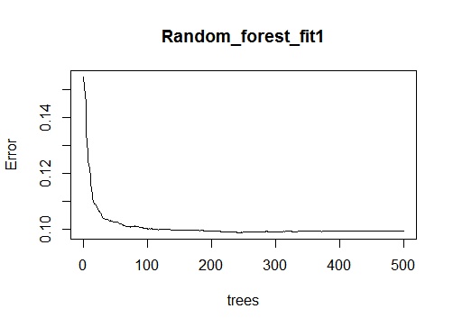
Tree based Model Result

> confusionMatrix(Allsec_dctree_test$Resigned.y,Dectree_prediction2)
Confusion Matrix and Statistics

Reference
Prediction 0 1
0 2292 224
1 410 396

Accuracy : 0.8092
95% CI : (0.7954, 0.8224)
No Information Rate : 0.8134
P-Value [Acc > NIR] : 0.7416

Kappa : 0.4365
Mcnemar's Test P-Value : 2.023e-13

Sensitivity : 0.8483
Specificity : 0.6387
Pos Pred Value : 0.9110
Neg Pred Value : 0.4913
Prevalence : 0.8134
Detection Rate : 0.6899
Detection Prevalence : 0.7574
Balanced Accuracy : 0.7435

'Positive' Class : 0

Modified Tree:

> confusionMatrix(Allsec_dctree_test$Resigned.y,Dectree_prediction2)
Confusion Matrix and Statistics

Reference
Prediction 0 1
0 2249 267
1 340 466

Accuracy : 0.8173
95% CI : (0.8037, 0.8303)
No Information Rate : 0.7793
P-Value [Acc > NIR] : 4.066e-08

Kappa : 0.487
Mcnemar's Test P-Value : 0.003474

Sensitivity : 0.8687
Specificity : 0.6357
Pos Pred Value : 0.8939
Neg Pred Value : 0.5782
Prevalence : 0.7793
Detection Rate : 0.6770
Detection Prevalence : 0.7574
Balanced Accuracy : 0.7522

'Positive' Class : 0

Regression Model:
1St Iteration: (Full model)

> summary(Reg_fit)

Call:
glm(formula = Resigned.y ~ ., family = binomial(link = "logit"),
data = Allsec_dctree_train, control = list(maxit = 50))

Deviance Residuals:
Min 1Q Median 3Q Max
-3.2051 -0.7753 -0.3323 -0.1866 2.5491

Coefficients:
Estimate Std. Error z value Pr(>|z|)
(Intercept) -0.571056 0.461460 -1.237 0.215902
Gender 0.009476 0.072239 0.131 0.895633
Marital.Status 0.055032 0.124441 0.442 0.658320
Highest.Educational.Qualification -0.004869 0.021849 -0.223 0.823658
Overall.Experience 0.055915 0.012046 4.642 3.45e-06 ***
Department.Technology -0.016727 0.004000 -4.181 2.90e-05 ***
Length.of.Service -0.189248 0.008442 -22.418 < 2e-16 ***
Job.title 0.033104 0.002462 13.444 < 2e-16 ***
Supporting.market 0.001302 0.001588 0.820 0.412469
Final_Age -0.040478 0.012072 -3.353 0.000799 ***
Region_2 -0.103906 0.013351 -7.783 7.10e-15 ***
Sal_bin1 1.293927 0.075746 17.082 < 2e-16 ***
---
Signif. codes: 0 ‘***’ 0.001 ‘**’ 0.01 ‘*’ 0.05 ‘.’ 0.1 ‘ ’ 1

(Dispersion parameter for binomial family taken to be 1)

Null deviance: 6877.0 on 6167 degrees of freedom
Residual deviance: 5212.9 on 6156 degrees of freedom
AIC: 5236.9

Number of Fisher Scoring iterations: 5

Important variables are Department, Overall Experience, and Length of service, Job title, Final Age, Sal bin and Region. Next iteration we are choosing the variables that are important only.

2nd Iteration:

ANOVA Test.

> anova(Regression_fit_1, test = "Chisq")
Analysis of Deviance Table

Model: binomial, link: logit

Response: Resigned.y

Terms added sequentially (first to last)

Df Deviance Resid. Df Resid. Dev Pr(>Chi)
NULL 6664 6828.0534
Overall.Experience 1 291.44902 6663 6536.6044 < 0.000000000000000222 ***
Length.of.Service 1 140.84385 6662 6395.7606 < 0.000000000000000222 ***
Job.title 1 575.02627 6661 5820.7343 < 0.000000000000000222 ***
Sal_bin 1 1339.26319 6660 4481.4711 < 0.000000000000000222 ***
Region_1 1 20.18481 6659 4461.2863 0.0000070309 ***
---
Signif. codes: 0 ‘***’ 0.001 ‘**’ 0.01 ‘*’ 0.05 ‘.’ 0.1 ‘ ’ 1

Regression Accuracy:

> confusionMatrix(Reg_pred, Allsec_dctree_test$Resigned.y)
Confusion Matrix and Statistics

Reference
Prediction 0 1
0 2404 579
1 112 227

Accuracy : 0.792
95% CI : (0.7778, 0.8057)
No Information Rate : 0.7574
P-Value [Acc > NIR] : 1.232e-06

Kappa : 0.2953
Mcnemar's Test P-Value : < 2.2e-16

Sensitivity : 0.9555
Specificity : 0.2816
Pos Pred Value : 0.8059
Neg Pred Value : 0.6696
Prevalence : 0.7574
Detection Rate : 0.7237
Detection Prevalence : 0.8980
Balanced Accuracy : 0.6186

'Positive' Class : 0

3. Neural Network.

Confusion Matrix and Statistics

Reference
Prediction 0 1
0 2023 337
1 208 289

Accuracy : 0.8092405
95% CI : (0.7943445, 0.8235001)
No Information Rate : 0.780889
P-Value [Acc > NIR] : 0.0001092934

Kappa : 0.3979256
Mcnemar's Test P-Value : 0.00000004183679

Sensitivity : 0.9067683
Specificity : 0.4616613
Pos Pred Value : 0.8572034
Neg Pred Value : 0.5814889
Prevalence : 0.7808890
Detection Rate : 0.7080854
Detection Prevalence : 0.8260413
Balanced Accuracy : 0.6842148

'Positive' Class : 0

Pos Pred Value : 0.7392093
Neg Pred Value : NaN
Prevalence : 0.7392093
Detection Rate : 0.7392093
Detection Prevalence : 1.0000000
Balanced Accuracy : 0.5000000

'Positive' Class : 1

Random Forest
Variable Importance.

> importance(Random_forest_fit1, type = 1)
%IncMSE
Gender 22.87862
Marital.Status 21.14393
Highest.Educational.Qualification 55.20841
Overall.Experience 26.14395
Department.Technology 56.95673
Length.of.Service 150.92525
Job.title 73.50227
Supporting.market 112.80964
Final_Age 58.42312
Sal_bin 78.92162
Region_1 59.08330

Random Forest Accuracy:

> confusionMatrix(Allsec_dctree_test$Resigned.y,Pred_rf1)
Confusion Matrix and Statistics

Reference
Prediction 0 1
0 2396 120
1 220 586

Accuracy : 0.8977
95% CI : (0.8868, 0.9078)
No Information Rate : 0.7875
P-Value [Acc > NIR] : < 2.2e-16

Kappa : 0.7093
Mcnemar's Test P-Value : 7.916e-08

Sensitivity : 0.9159
Specificity : 0.8300
Pos Pred Value : 0.9523
Neg Pred Value : 0.7270
Prevalence : 0.7875
Detection Rate : 0.7213
Detection Prevalence : 0.7574
Balanced Accuracy : 0.8730

'Positive' Class : 0

`SVM

Parameter tuning of ‘svm’:

- sampling method: fixed training/validation set

- best parameters:
gamma cost
0.5 4

- best performance: 0.1165827878

- Detailed performance results:
gamma cost error dispersion
1 0.5 4 0.1165827878 NA
2 1.0 4 0.1235520382 NA
3 2.0 4 0.1320774640 NA
4 0.5 8 0.1216656544 NA
5 1.0 8 0.1309994588 NA
6 2.0 8 0.1360848890 NA
7 0.5 16 0.1295559201 NA
8 1.0 16 0.1379669351 NA
9 2.0 16 0.1436688413 NA
SVM Accuracy:

> confusionMatrix(pred_svm, Allsec_dctree_test$Resigned.y)
Confusion Matrix and Statistics

Reference
Prediction 0 1
0 2367 542
1 149 264

Accuracy : 0.792
95% CI : (0.7778, 0.8057)
No Information Rate : 0.7574
P-Value [Acc > NIR] : 1.232e-06

Kappa : 0.3216
Mcnemar's Test P-Value : < 2.2e-16

Sensitivity : 0.9408
Specificity : 0.3275
Pos Pred Value : 0.8137
Neg Pred Value : 0.6392
Prevalence : 0.7574
Detection Rate : 0.7125
Detection Prevalence : 0.8757
Balanced Accuracy : 0.6342

'Positive' Class : 0

With Full Dataset
> confusionMatrix(pred_svm, Fulldata$Resigned.y)
Confusion Matrix and Statistics

Reference
Prediction 0 1
0 6795 1520
1 374 801

Accuracy : 0.8004
95% CI : (0.7922, 0.8084)
No Information Rate : 0.7554
P-Value [Acc > NIR] : < 2.2e-16

Kappa : 0.3516
Mcnemar's Test P-Value : < 2.2e-16

Sensitivity : 0.9478
Specificity : 0.3451
Pos Pred Value : 0.8172
Neg Pred Value : 0.6817
Prevalence : 0.7554
Detection Rate : 0.7160
Detection Prevalence : 0.8762
Balanced Accuracy : 0.6465

'Positive' Class : 0
Time Series:
R code:
Time Series.R
For Chennai Location:
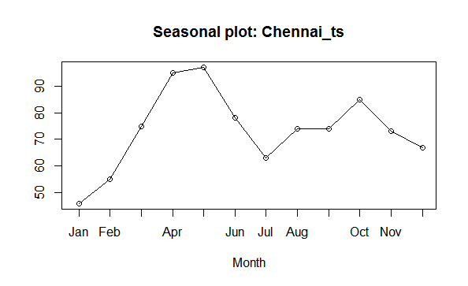
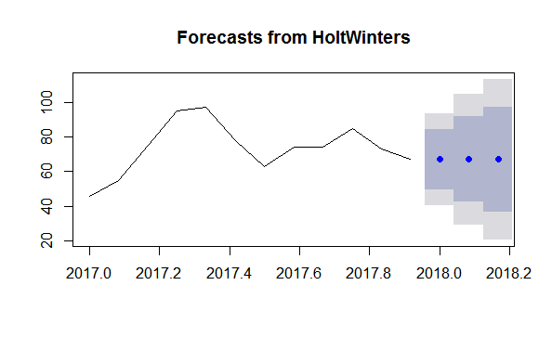
> forecast(fit1, 3)
Point Forecast Lo 80 Hi 80 Lo 95 Hi 95
Jan 2018 67.0004 49.55534 84.44545 40.32049 93.6803
Feb 2018 67.0004 42.33018 91.67061 29.27056 104.7302
Mar 2018 67.0004 36.78601 97.21478 20.79148 113.2093
For Bangalore Location:
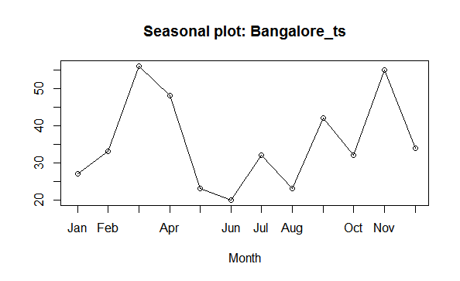

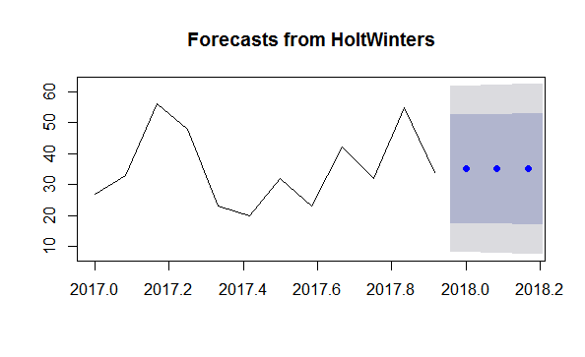
> forecast(fit2, 3)
Point Forecast Lo 80 Hi 80 Lo 95 Hi 95
Jan 2018 35.01909 17.48505 52.55314 8.203086 61.83510
Feb 2018 35.01909 17.28877 52.74942 7.902909 62.13528
Mar 2018 35.01909 17.09465 52.94354 7.606019 62.43217

For Delhi Location:
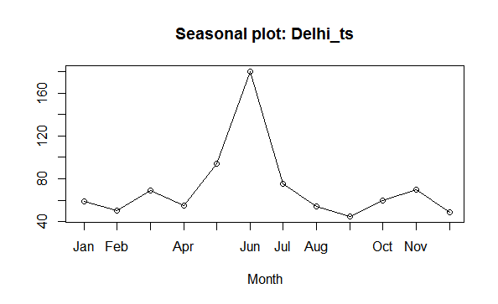

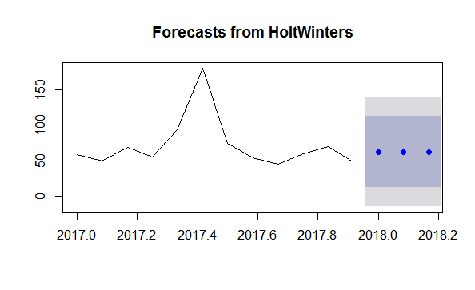
> forecast(fit3, 3)
Point Forecast Lo 80 Hi 80 Lo 95 Hi 95
Jan 2018 62.717 12.67375 112.7602 -13.81755 139.2515
Feb 2018 62.717 12.65174 112.7823 -13.85120 139.2852
Mar 2018 62.717 12.62975 112.8042 -13.88484 139.3188

Allsec Attrition as a whole:

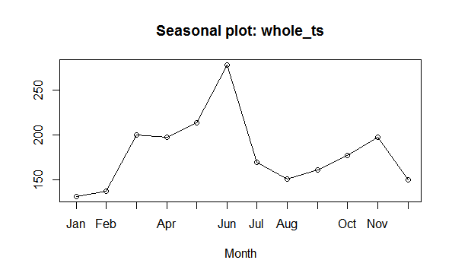

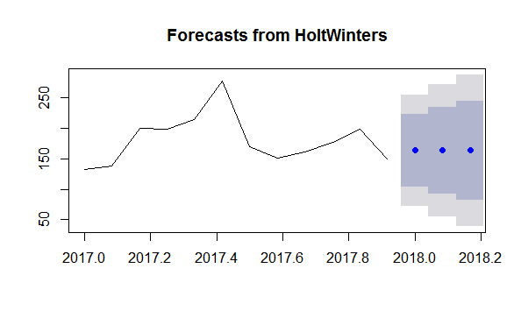

> forecast(fit4, 3)
Point Forecast Lo 80 Hi 80 Lo 95 Hi 95
Jan 2 163.5422 103.91038 223.1739 72.34322 254.7411
Feb 2 163.5422 92.30904 234.7753 54.60050 272.4838
Mar 2 163.5422 82.34877 244.7355 39.36759 287.7167

